Alex Arnold
Professor Torres
2-15-25
IT 0115-41197
Lab 3

Part A:
Install Linux Server (for this section you a following along with the Netlab lab)

Log on the Netlabv2Links to an external site. and select NISGTC Linux+ Install
This netlab has the same username as the Netlabv1 environment with the temp password of Serversrock1
Use Lab 01a lab and Install CentOS Server OS
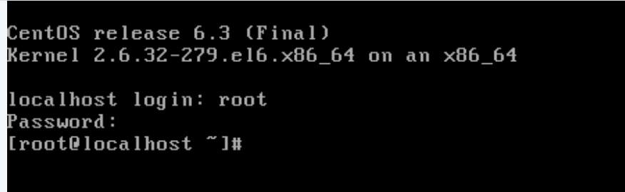
- Centos installed
Use Lab 01b lab and install Ubuntu Desktop OS
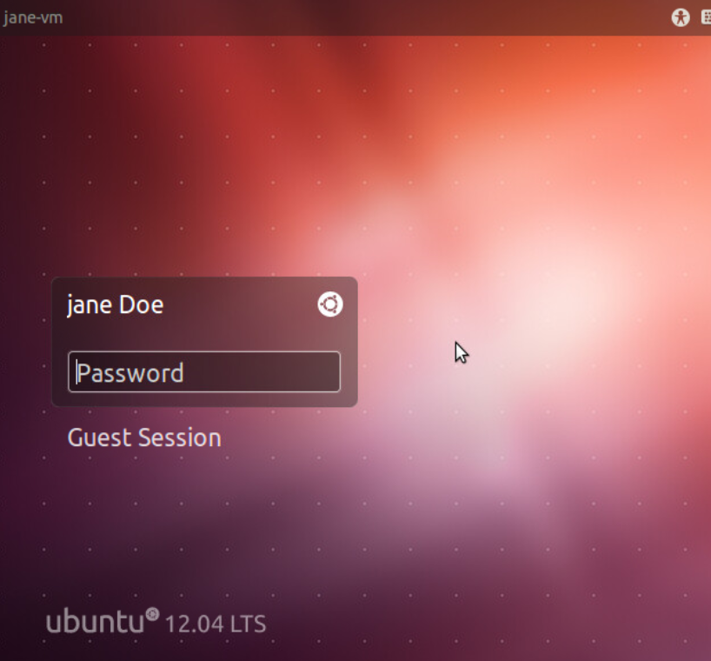
- Ubuntu installed

Part B:
Use google to research on how to make the below changes (log onto Lab Linux+ Series 1 for part B and C:
On the CentOS Server
change the hostname to Justice
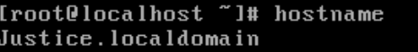
- Hostname set to Justice
Reboot the system
change the IP of Ethernet0 to 192.168.0.230/24, DNS=192.168.0.1, gateway=192.168.0.1 using the Server Manager
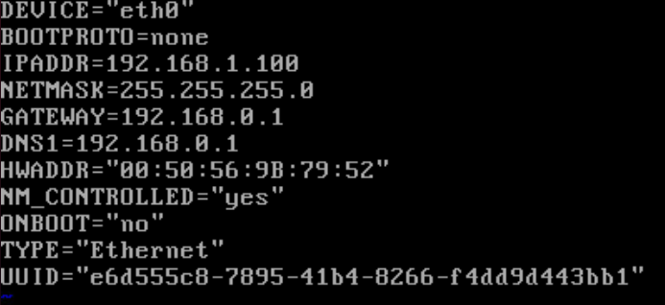
- Eth0 changed
On the Ubuntu Server
change the hostname to Avengers
Reboot the system
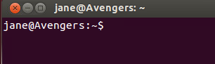
change the IP to 192.168.0.231/24 (add the default gateway and DNS of 192.168.0.1)
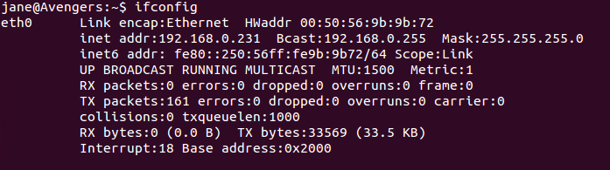
ETH0 changed
Part C:
Answer the below questions for the CentOS and Ubuntu Server via the command line. Provide screenshots:
Centos
How much hard drive space is on the server
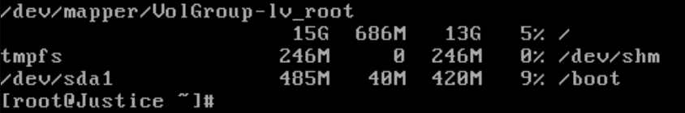
How much memory is on the server
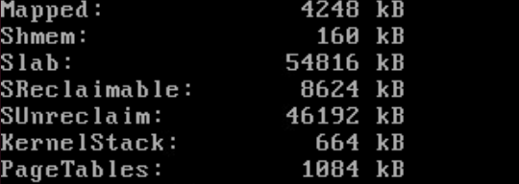
What processor is on the server
List the users on the system
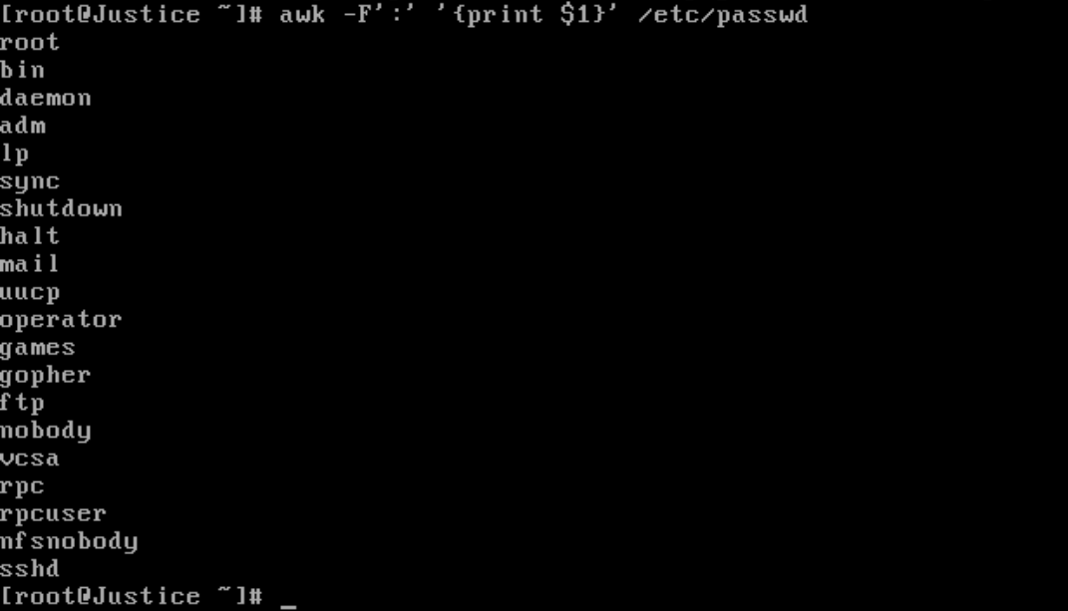
List the hostname for the server

List the IP address on the server
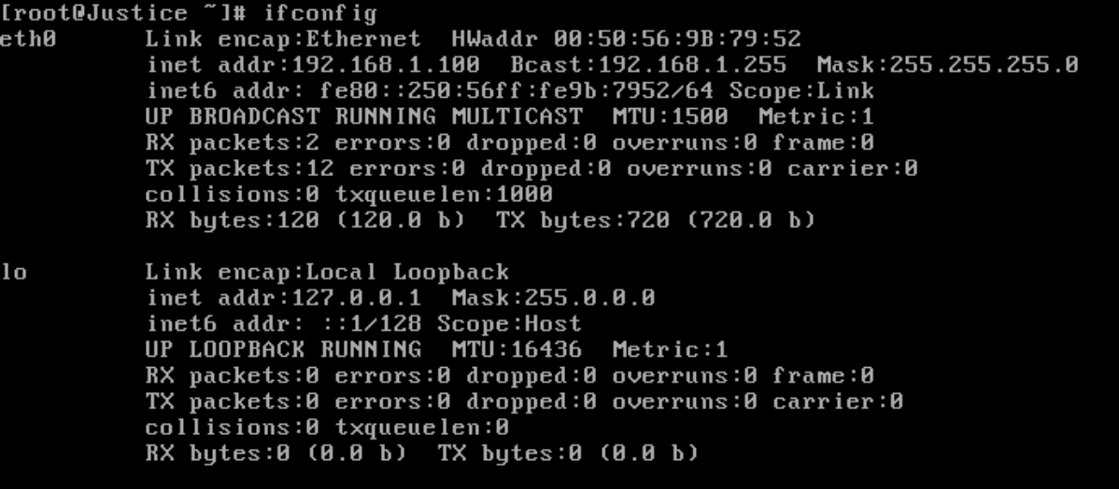

Ubuntu
How much hard drive space is on the server
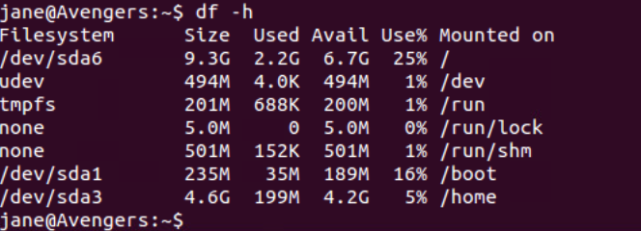
How much memory is on the server
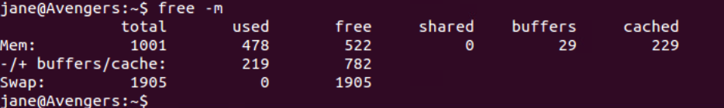
What processor is on the server
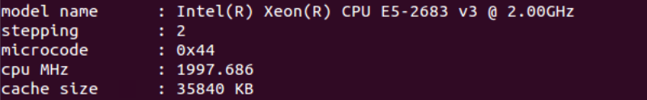
List the users on the system
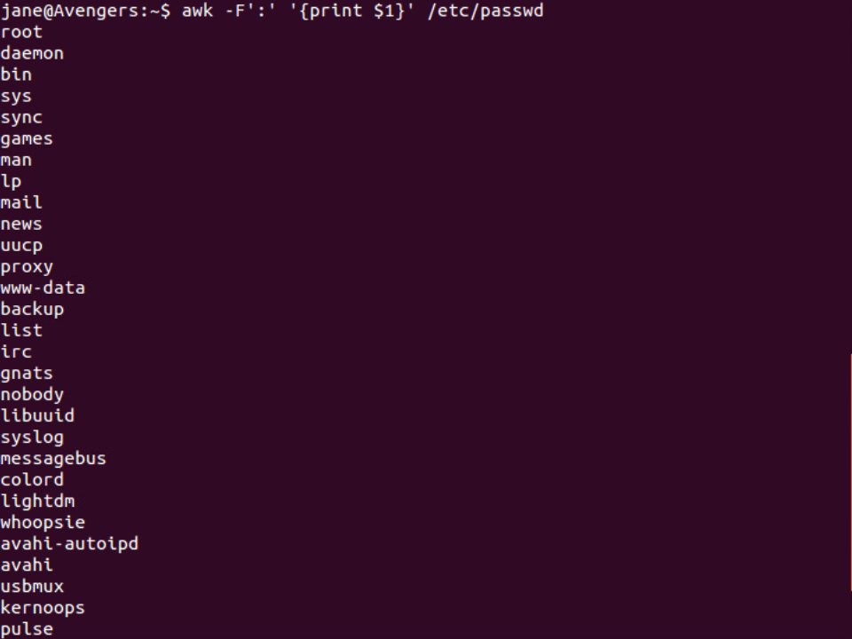
List the hostname for the server

List the IP address on the server

Extra Credit
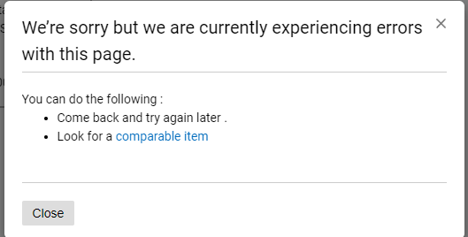
Message I get when I try to edit the configuration on the page.

